𝐂𝐨𝐝𝐞 𝐒𝐧𝐢𝐩𝐩𝐞𝐭𝐬 (𝐀𝐮𝐭𝐨 𝐂𝐨𝐦𝐩𝐥𝐞𝐭𝐞)

- 𝐂𝐭𝐫𝐥 + 𝐒𝐩𝐚𝐜𝐞 = Auto Complete Work
- syso
- main
- for
- foreach
- while
- do
- if
𝐅𝐮𝐧𝐜𝐭𝐢𝐨𝐧 𝐊𝐞𝐲𝐬 𝐎𝐧𝐥𝐲

- 𝐅𝟑 = Definition at current cursor/selected
- 𝐅𝟔 = Debugging line by line (Step Over)
- 𝐅𝟓 = Go inside method while debugging (Step Into)
- 𝐅𝟖 = Resume / Exit debug section
- 𝐂𝐭𝐫𝐥 + 𝐅𝟏𝟏 = Run the Program
- 𝐅𝟏𝟏 = Debug the Program
- 𝐅𝐧 + 𝐏𝐠𝐔𝐩 / 𝐏𝐠𝐃𝐧 = One screen page up/down
- 𝐂𝐭𝐫𝐥 + 𝐅2 = Kill the Debugging Process.
- 𝐂𝐭𝐫𝐥 + 𝐅2 + F11 = After kill start again Debugging.

𝐑𝐢𝐠𝐡𝐭 𝐂𝐥𝐢𝐜𝐤 (𝐂𝐨𝐝𝐞 𝐆𝐞𝐧𝐞𝐫𝐚𝐭𝐢𝐨𝐧)

- Right Click → Source → Generate Getters & Setters

𝐂𝐭𝐫𝐥 +

- 𝐂𝐭𝐫𝐥 + +/- = Zoom In / Out
- 𝐂𝐭𝐫𝐥 + / = Single line comment/uncomment
- 𝐂𝐭𝐫𝐥 + 𝐏𝐠𝐔𝐩 / 𝐏𝐠𝐃𝐧 = Scroll without moving cursor
- 𝐂𝐭𝐫𝐥 + 𝐂𝐥𝐢𝐜𝐤 = Go to definition (method/variable)
- 𝐂𝐭𝐫𝐥 + 𝐃 = Delete entire row
- 𝐂𝐭𝐫𝐥 + 𝐄 = Show all opened files (file switcher)
- 𝐂𝐭𝐫𝐥 + 𝐅 = Find
- 𝐂𝐭𝐫𝐥 + 𝐈 = Correct indentation
- 𝐂𝐭𝐫𝐥 + 𝐋 = Go to line
- 𝐂𝐭𝐫𝐥 + 𝐌 = Maximize / Minimize editor
- 𝐂𝐭𝐫𝐥 + 𝐍 = New file/class/package
- 𝐂𝐭𝐫𝐥 + 𝐎 = Show all methods (Outline)
- Ctrl + Q = Shows the last edit
- Ctrl + T = Shows the Hierarchy of that class.
- 𝐂𝐭𝐫𝐥 + 𝐖 = Close file
- 𝐂𝐭𝐫𝐥 + 𝟏 = Quick Fix
𝐂𝐭𝐫𝐥 + 𝐒𝐡𝐢𝐟𝐭 +

- 𝐂𝐭𝐫𝐥 + 𝐒𝐡𝐢𝐟𝐭 + 𝐅 = Format code
- 𝐂𝐭𝐫𝐥 + 𝐒𝐡𝐢𝐟𝐭 + K = Previous Occurrences of Selected variable.
- 𝐂𝐭𝐫𝐥 + 𝐒𝐡𝐢𝐟𝐭 + 𝐋 = Show all keyboard shortcuts
- 𝐂𝐭𝐫𝐥 + 𝐒𝐡𝐢𝐟𝐭 + 𝐎 = Organize imports(Auto Imports)
- 𝐂𝐭𝐫𝐥 + 𝐒𝐡𝐢𝐟𝐭 + 𝐏 = Jump to matching bracket (})
- 𝐂𝐭𝐫𝐥 + 𝐒𝐡𝐢𝐟𝐭 + 𝐑 = Search file (File Search)
- 𝐂𝐭𝐫𝐥 + 𝐒𝐡𝐢𝐟𝐭 + 𝐒 = Save All
- 𝐂𝐭𝐫𝐥 + 𝐒𝐡𝐢𝐟𝐭 + 𝐓 = Search class (Class Search)
- 𝐂𝐭𝐫𝐥 + 𝐒𝐡𝐢𝐟𝐭 + 𝐖 = Close all files
- 𝐂𝐭𝐫𝐥 + 𝐒𝐡𝐢𝐟𝐭 + 𝐗 = Convert to UPPERCASE
- 𝐂𝐭𝐫𝐥 + 𝐒𝐡𝐢𝐟𝐭 + 𝐘 = Convert to lowercase
- 𝐂𝐭𝐫𝐥 + 𝐒𝐡𝐢𝐟𝐭 + / = multi-line comment
- 𝐂𝐭𝐫𝐥 + 𝐒𝐡𝐢𝐟𝐭 + \ = Remove multi-line comment.
- 𝐂𝐭𝐫𝐥 + 𝐒𝐡𝐢𝐟𝐭 + Func + ↑ / ↓ = For go/back on all tabs opened in order and displayed
- 𝐂𝐭𝐫𝐥 + 𝐒𝐡𝐢𝐟𝐭 + Enter = For Insert Blank Line

𝐂𝐭𝐫𝐥 + 𝐀𝐥𝐭 +

- 𝐂𝐭𝐫𝐥 + 𝐀𝐥𝐭 + 𝐇 = Type hierarchy
- Ctrl + Alt + ↑ / ↓ = for copying the same line Above/Below

𝐀𝐥𝐭 +

- 𝐀𝐥𝐭 + ↑ / ↓ = Move line up/down
- 𝐀𝐥𝐭 + ← / → = Navigation history (Back/Forward)
- 𝐀𝐥𝐭 + 𝐅 → 𝐗 = Close Eclipse (fast)
- Alt + click – for cursor on occurences where to change.

𝐀𝐥𝐭 + Accessing Title Bar
  - Alt + F = Open File Tab
  - Alt + E = Edit
  - Alt + S = Source
  - Alt + R = Refactor
  - Alt + N = Navigate
  - Alt + P = Project
  - Alt + W = Window
  - Alt + H = Help

𝐀𝐥𝐭 + 𝐒𝐡𝐢𝐟𝐭 +

- 𝐀𝐥𝐭 + 𝐒𝐡𝐢𝐟𝐭 + 𝐀 + 𝐒𝐡𝐢𝐟𝐭 + ↑/↓ = Multi-line editing (block selection)
- 𝐀𝐥𝐭 + 𝐒𝐡𝐢𝐟𝐭 + B = Show/Hide BreadCrumb(Directory path in program upper tab)
- 𝐀𝐥𝐭 + 𝐒𝐡𝐢𝐟𝐭 + 𝐃 + 𝐉 = Debug program
- 𝐀𝐥𝐭 + 𝐒𝐡𝐢𝐟𝐭 + 𝐌 = Extract method
- 𝐀𝐥𝐭 + 𝐒𝐡𝐢𝐟𝐭 + Q + P = File Explorer Clearly visible
- 𝐀𝐥𝐭 + 𝐒𝐡𝐢𝐟𝐭 + 𝐑 = Rename (all occurrences) of same word/Edit All Occrences/ Refactor
- 𝐀𝐥𝐭 + 𝐒𝐡𝐢𝐟𝐭 + 𝐑 (twice) = Rename class/method
- 𝐀𝐥𝐭 + 𝐒𝐡𝐢𝐟𝐭 + 𝐒 → 𝐑 = Generate Getters & Setters
- 𝐀𝐥𝐭 + 𝐒𝐡𝐢𝐟𝐭 + 𝐒 → S = for generate toString method, of selected Strings.
- 𝐀𝐥𝐭 + 𝐒𝐡𝐢𝐟𝐭 + 𝐒 → O = Generate Constructor of created variables and all.
- 𝐀𝐥𝐭 + 𝐒𝐡𝐢𝐟𝐭 + 𝐓 = Refactor options menu
- 𝐀𝐥𝐭 + 𝐒𝐡𝐢𝐟𝐭 + 𝐗 + 𝐉 = Run Java Application
- 𝐀𝐥𝐭 + 𝐒𝐡𝐢𝐟𝐭 + 𝐗 + 𝐑 = Run on Server
- 𝐀𝐥𝐭 + 𝐒𝐡𝐢𝐟𝐭 + 𝐙 = Surround with (try-catch / loops / conditionals)

𝐒𝐡𝐢𝐟𝐭 +

- 𝐒𝐡𝐢𝐟𝐭 + 𝐇𝐨𝐦𝐞 / 𝐄𝐧𝐝 = Select line start/end

Custom Created Similar to my VS Code Snippet+
Ctrl + R = Refresh the window.
Ctrl + ‘= Run the Program. – Run Java Application.
Ctrl + Shift + ‘= Run on Server.
Ctrl + K = Clear Console (Output stuff from console).
Alt + J = Multi Cursor Selection one by one.
Ctrl + Tab = Next Editor
Ctrl + Shift + Tab = Previous Editor

Additional Theme/ Plugin Installed

Plugins - AnyEdit
Themes – DevStyle

Settings Upgraded as per requirements –
  - For methid name, variable name suggections while reusing after declaration
Before changes – 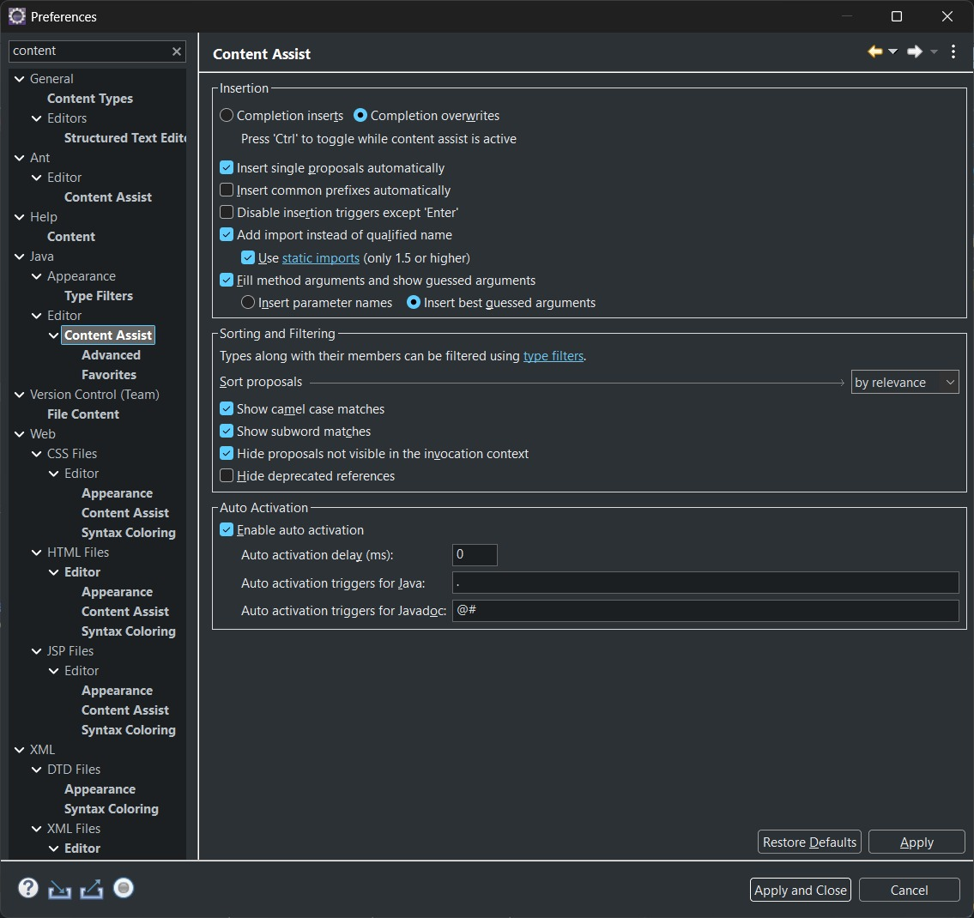
After changes -
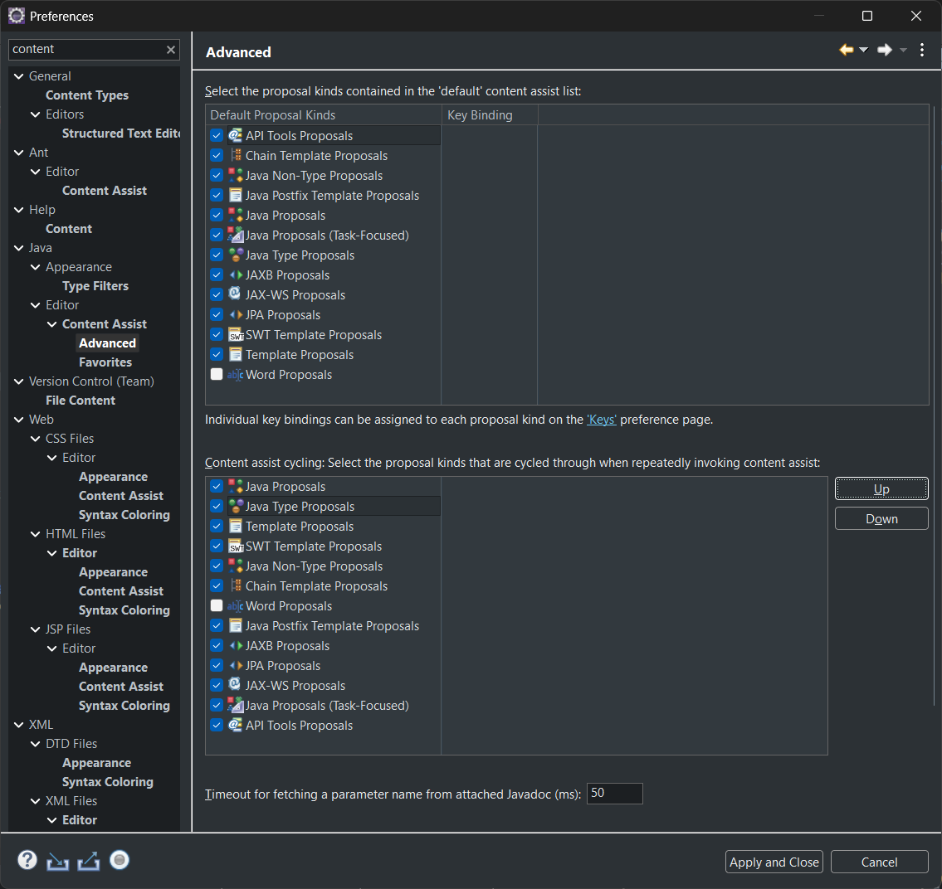
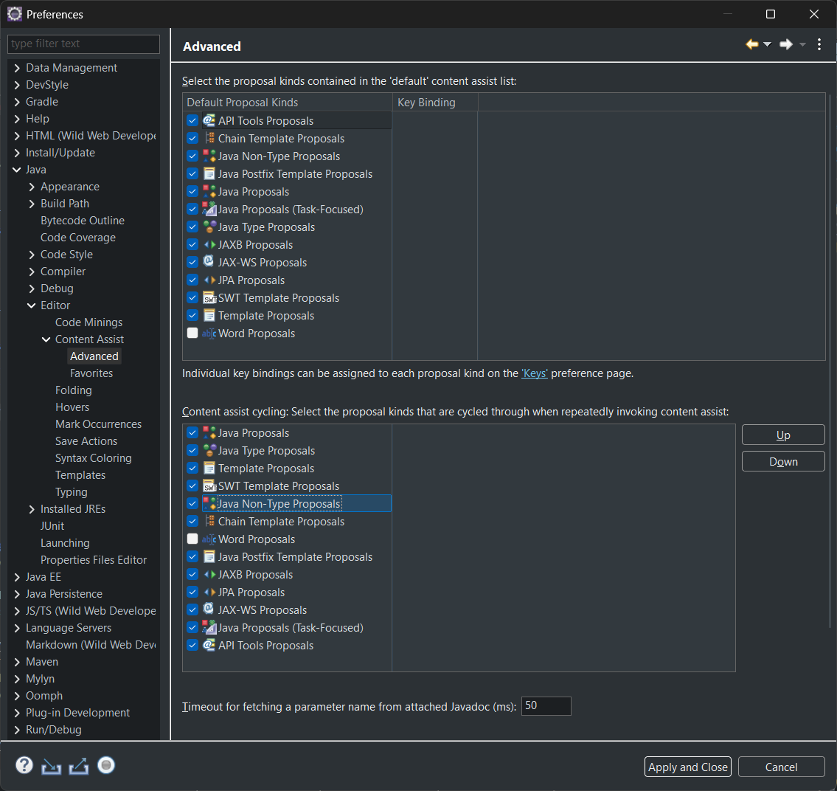

  - Font upgraded like VS -
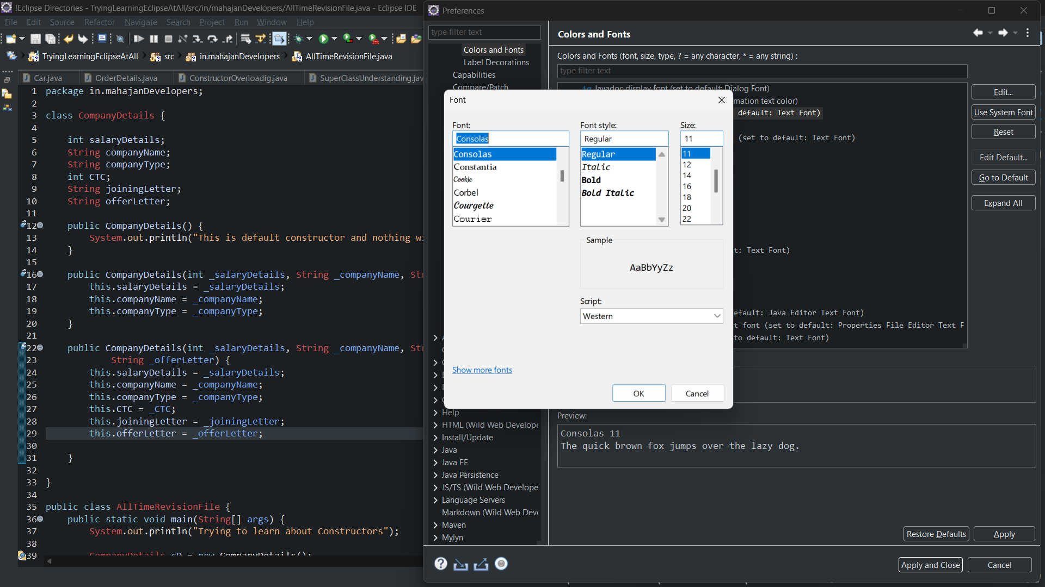
  - While debugging in devstyle dark –
Color highlight for debugger line
Red: 120
Green: 140
Blue: 40
👉 🟡 Arrow
👉 🟢 Yellow-Green line

Red: 100
Green: 120
Blue: 30

Red: 70
Green: 85
Blue: 100

Changes made –

🧾 FINAL ECLIPSE SETUP (Complete Work Done)
- Dark theme install kiya (clean, distraction-free UI).
- UI minimal rakha (extra clutter avoid kiya).
- Font issue identify kiya (Consolas 11/12 imbalance).
- JetBrains Mono install + apply kiya (better readability).
- Content Assist auto activation ON kiya.
- Auto activation delay 0 ms set kiya.
- Triggers expand kiye:
abcdefghijklmnopqrstuvwxyzABCDEFGHIJKLMNOPQRSTUVWXYZ.
- Camel case matching enable kiya.
- Subword matching enable kiya.
- VS Code jaisa variable suggestion behavior achieve kiya.
- Breadcrumb feature samjha + preference-based control choose kiya.
- UI clean rakhne ke liye shortcut-based breadcrumb avoid kiya.
- Debugging issue samjha (JVM/internal code jump).
- Step Over (F6) based debugging approach adopt kiya.
- Debugging flow clarity improve ki (user code vs system code).
- Java version & project info check karna sikha.
- Default keybindings ko preserve karne ka decision liya.
- Console copy ke liye risky shortcut override avoid kiya.
- Custom VS Code-like shortcuts safely add kiye:
- Ctrl + R → Refresh
- Ctrl + ' → Run Java Application
- Ctrl + Shift + ' → Run on Server
- Ctrl + K → Clear Console
- Ctrl + Tab → Next Editor
- Ctrl + Shift + Tab → Previous Editor
- Font scaling limitation samjha + JetBrains Mono se solve kiya.
- Overall philosophy set ki: UI customize karo, core system untouched rakho.

Prompt –

I want to configure my IDE (Eclipse / IntelliJ / VS Code) with a clean, minimal, and professional Java development setup. Please guide me step-by-step to achieve this exactly, without breaking default core IDE behavior.
🎯 Goal
Create a VS Code-like smooth experience with strong autocomplete, readable fonts, stable debugging, and safe customization.
🎨 Theme & UI
- Use a Dark Theme.
- Keep UI minimal and distraction-free.
- Avoid unnecessary panels and clutter.
🔤 Font & Readability
- Font: JetBrains Mono.
- Preferred size:
  - 11 OR
  - 12 with slight zoom adjustment.
- Goal: balanced readability (not too small, not too large).
⚙️ Code Suggestions (Autocomplete)
- Enable auto suggestions.
- Set delay to 0 ms.
- Enable suggestions while typing (not only on dot).
- Use triggers:
abcdefghijklmnopqrstuvwxyzABCDEFGHIJKLMNOPQRSTUVWXYZ.
- Enable:
  - Camel case matching.
  - Subword matching.
- Expected behavior:
Typing partial text like "sal" should suggest variables like "salaryDetails".
🧠 Suggestion Philosophy
- Keep default suggestion system intact.
- Do NOT remove built-in proposal types.
- Only prioritize relevant suggestions via ordering, not removal.
🧭 Navigation
- Use Project Explorer for structure.
- Breadcrumb optional, but control via settings only (avoid shortcut toggles).
🐞 Debugging Setup
- Use F6 (Step Over) as primary debugging key.
- Avoid excessive Step Into (F5).
- Understand that debugger entering java.lang or internal JVM code is normal.
- Focus only on application-level execution flow.
⌨️ Keybindings (Custom but Safe)
Add these shortcuts without overriding core defaults:
- Ctrl + R → Refresh
- Ctrl + ' → Run Java Application
- Ctrl + Shift + ' → Run on Server
- Ctrl + K → Clear Console
- Ctrl + Tab → Next Editor
- Ctrl + Shift + Tab → Previous Editor
🖥️ Console Behavior
- Use default copy methods (Ctrl + C or context menu).
- Avoid overriding core copy shortcuts.
🎯 Philosophy
- Customize only UI and comfort settings.
- Keep core IDE behavior unchanged.
- Ensure long-term stability (3–4 years usage).
- Prefer safe, reversible configurations.
Please provide:
- Exact steps to configure this setup.
- IDE-specific adjustments if needed.
- Only safe and recommended practices.

